**“Civics and Community Project Report”**

**“Ramadan Iftar Drive 2k25”**



**“Submitted By”**

**Muhammad Maauz Mansoor (233599)**

**“SUBMITTED TO”**

**Sir Waqar Arshad**

**DEPARTMENT OF COMPUTER SCIENCE**

**AIR UNIVERSITY MULTAN CAMPUS**

**April 2025**

## “🌟 Table Of Contents 🌟”

Table of Contents

“🌟 Table Of Contents 🌟” 2

“🌟 Executive Summary 🌟” 3

“🌟 Introduction 🌟” 4

“🌟 Project Objective 🌟” 4

“🌟 Planning & Preparation 🌟” 4

“🌟 Execution & Location 🌟” 5

“🌟 Visual Evidence 🌟” 6

6

“🌟 High-Lights Iftar-01🌟” 7

“🌟 High-Lights Iftar-02🌟” 8

“🌟 High-Lights Iftar-03🌟” 9

“🌟 Budget & Resources 🌟” 10

“🌟 Community Impact & Feedback 🌟” 18

“🌟 Conclusion 🌟” 18

“🌟 Acknowledgment 🌟” 19

“🌙 Final Reflection 🌟” 19

“🌟 Video Links 🌟” 20

“🌟 My-Certificate 🌟” 21

“🌟 Other-Certificates 🌟” 22

The End ! 26

## “🌟 Executive Summary 🌟”

The **Ramadan Iftar Drive 2025** is a heartwarming example of how youth-led initiatives can bring about real and meaningful change in society. Organized under the umbrella of the **Civics and Community course** at **Air University Multan**, this project was more than just an assignment — it was a journey of service, empathy, and unity. In collaboration with three active and socially driven organizations — **RSWS**, **RAS Society**, and **BZU’s student society** — we took on the responsibility of arranging free Iftar meals every Sunday of Ramadan for the fasting individuals of Multan, especially those who couldn’t afford a proper meal or were away from home.

The foundation of this project lay in the values of compassion and collective effort. Weeks before Ramadan began, our teams engaged in active discussions, planning meetings, budget estimations, location assessments, and volunteer coordination. Special attention was paid to identifying **locations with high footfall and need**, such as **Nishtar Hospital**, where hundreds of patients’ attendants and workers often miss Iftar due to circumstances beyond their control.

Every Sunday, our volunteers reached the site two hours before Iftar to set up the space, unpack and arrange the Iftar items, and ensure everything ran smoothly. The Iftar boxes included essentials such as **dates,water bottles**, and a **main meal like biryani or pulao**. It was not just about food — it was about **serving with respect and kindness**, creating an environment where people felt cared for, even by strangers.

The emotional and spiritual rewards were overwhelming. The smiles on people’s faces, the heartfelt duas (prayers), and the silent sense of relief they experienced reminded us of our shared humanity. Volunteers expressed how this initiative gave them a sense of responsibility and purpose, motivating them to continue serving society even beyond this course.

Moreover, this project helped build strong inter-university collaboration. Students from different institutions worked as one team, showing how youth from various backgrounds can unite for a noble cause. The drive also served as a live demonstration of community mobilization, logistical planning, teamwork, leadership, and time management.

This report presents a detailed overview of the Iftar Drive’s objectives, planning, execution, financial structure, community engagement, and visual documentation. It is not just a project summary; it’s a reflection of how impactful community service can be when done with sincerity, structure, and collaboration. The **Ramadan Iftar Drive 2025** has left a lasting imprint on our hearts and has inspired us to take more such steps towards creating a more compassionate and united society.

**“Qoute”**

***“The best of people are those who bring the most benefit to others.”***

***Prophet Muhammad (PBUH)***

## “🌟 Introduction 🌟”

**As part of the Civics and Community course, I initiated and executed a large-scale Iftar Drive throughout the holy month of Ramadan 2025. Collaborating with RSWS, RAS Society, and BZU's student society, we successfully arranged Iftar for over 1000 people every Sunday. This project aimed to serve the community, promote unity, and revive the spirit of giving.**

## “🌟 Project Objective 🌟”

* **To promote the spirit of community welfare and empathy during the holy month of Ramadan.**
* **To provide Iftar to the underprivileged and fasting individuals in Multan.**
* **To involve students in meaningful social responsibility initiatives.**
* **To collaborate with multiple societies to ensure maximum impact.**

## “🌟 Planning & Preparation 🌟”

**Weeks before Ramadan, we started planning with RSWS and RAS Society. Key steps included:**

* **Selecting locations across Multan with high footfall.**
* **Budget planning and fundraising.**
* **Volunteering teams formation.**
* **Procurement of Iftar items.**
* **Daily coordination with society heads.**

## “🌟 Execution & Location 🌟”

**Each Sunday, our team set up Iftar at Nishter Hospital. Our volunteers reached the spot 2 hours before Maghrib to prepare and arrange everything. Each spot served over 1000 people, distributing dates, and biryani boxes.**

## “🌟 Visual Evidence 🌟”

## 

## “🌟 High-Lights Iftar-01🌟”

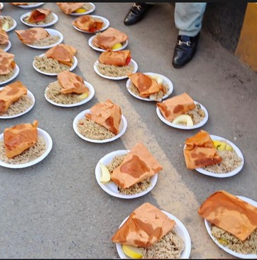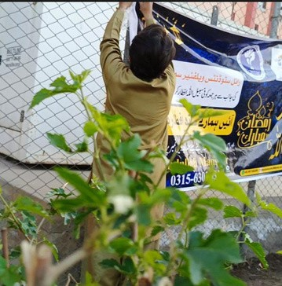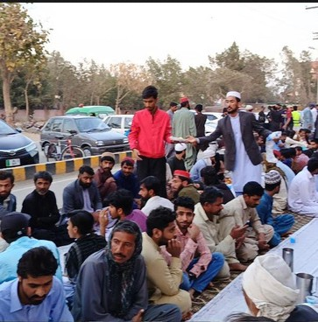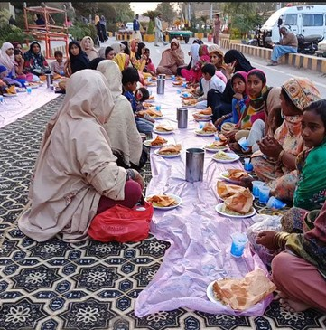

## “🌟 High-Lights Iftar-02🌟”

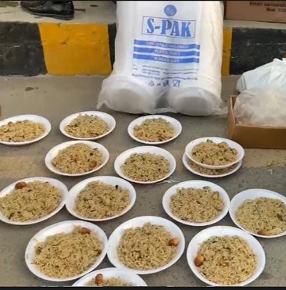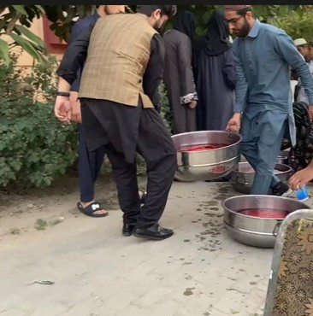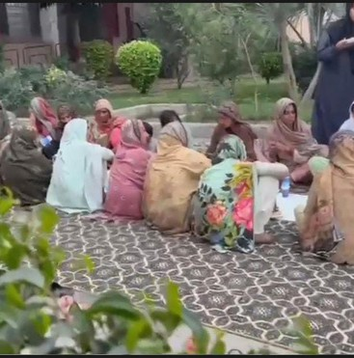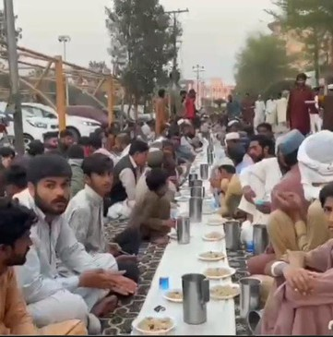

## “🌟 High-Lights Iftar-03🌟”

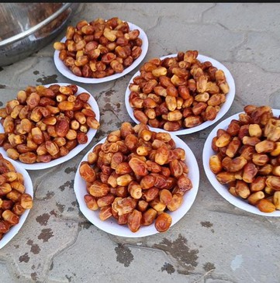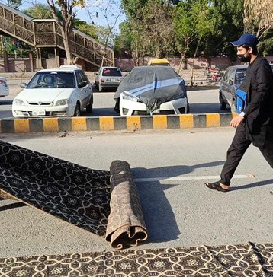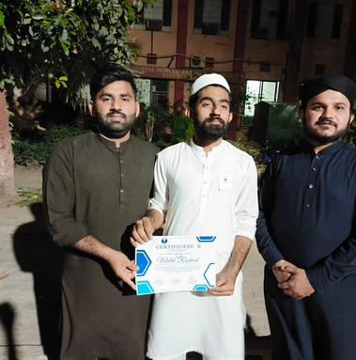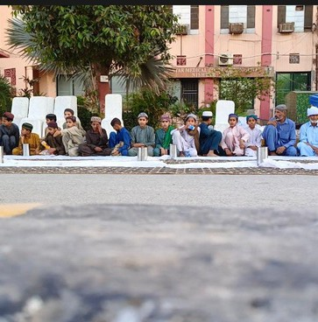

## “🌟 Budget & Resources 🌟”

**“Donation Record””**

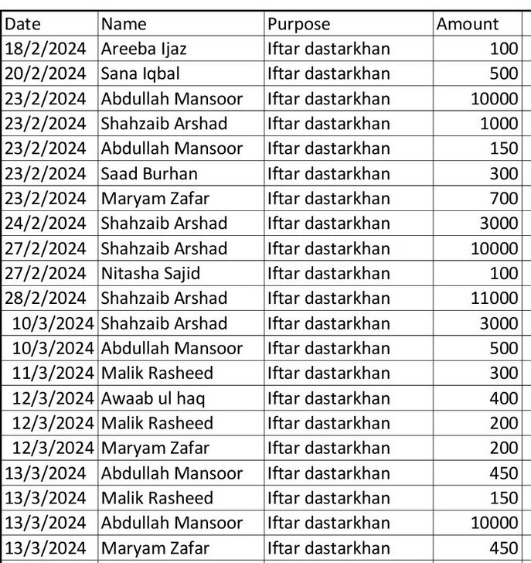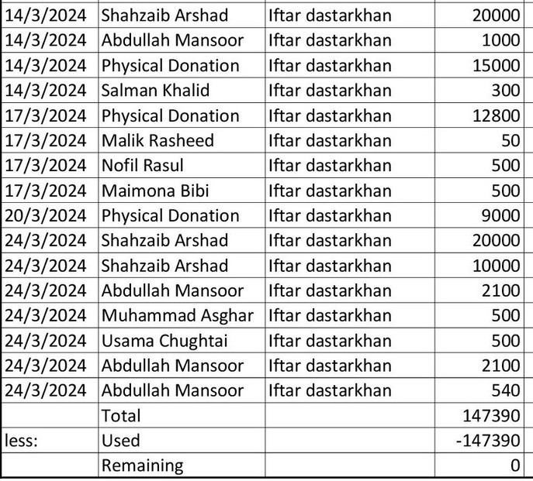

**“Expense Record Iftar-01””**

**“Expense Proof Iftar-01””**

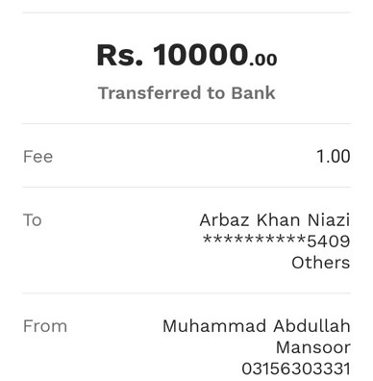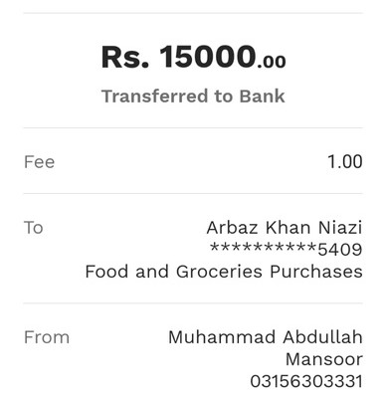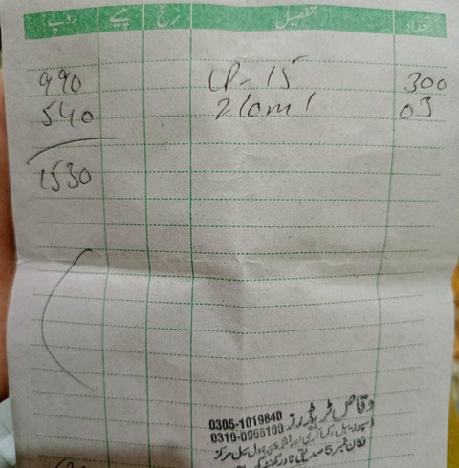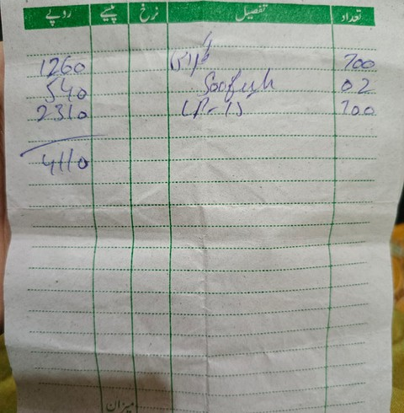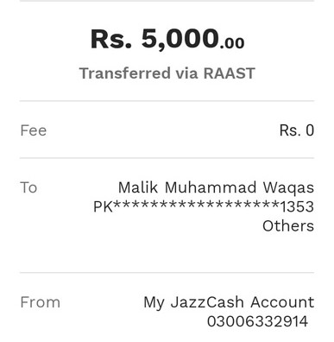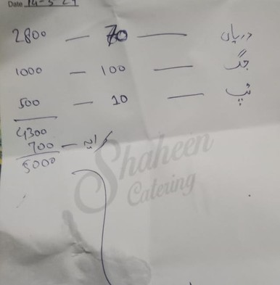

**“Expense Record Iftar-02””**

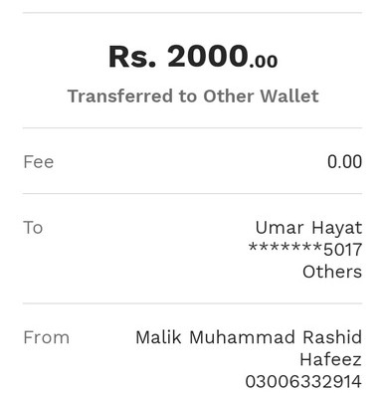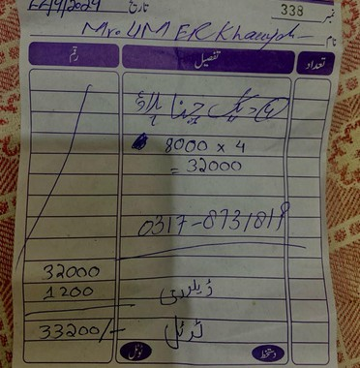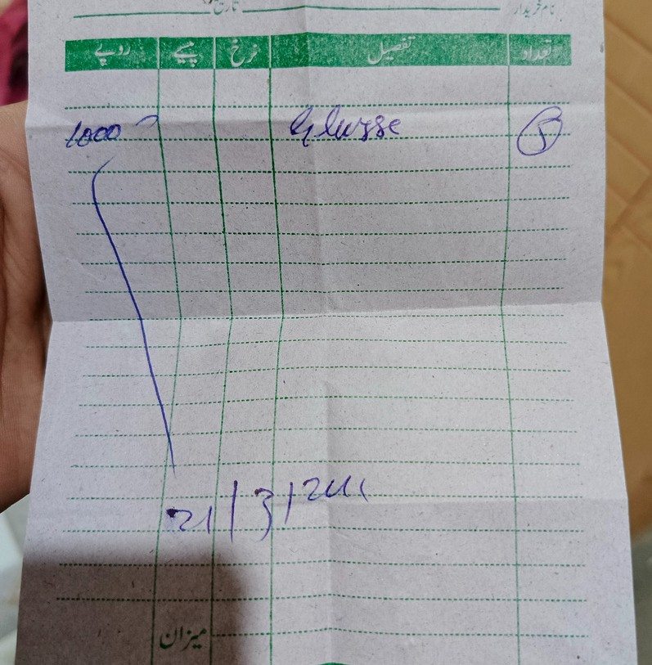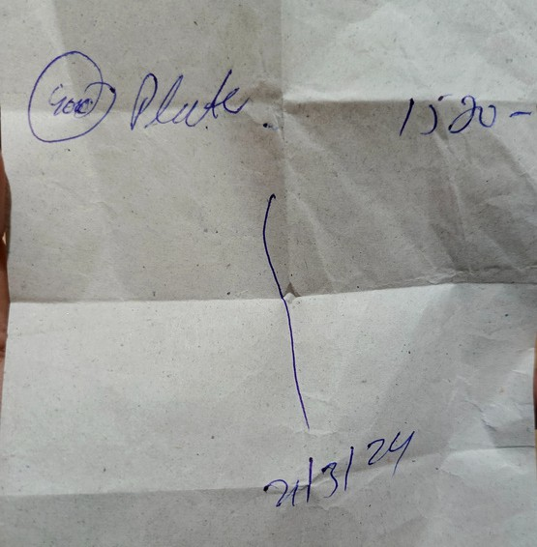

**“Expense Proof Iftar-02””**

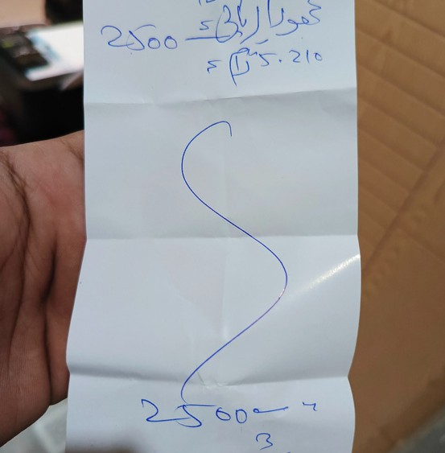

**“Expense Record Iftar-03””**

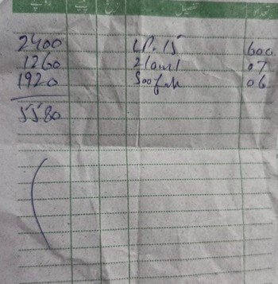

**“Expense Proof Iftar-03””**

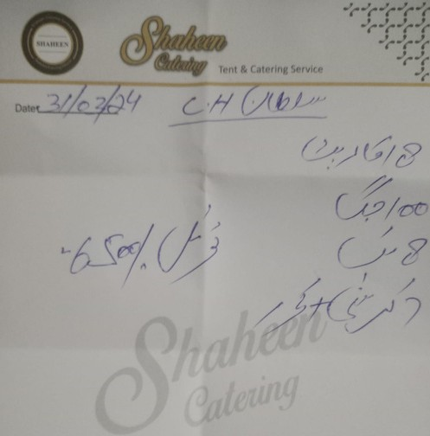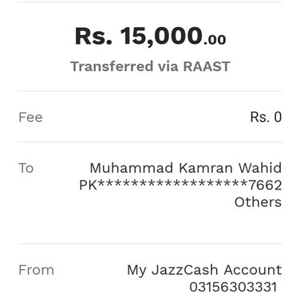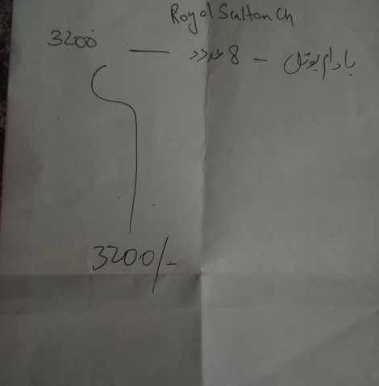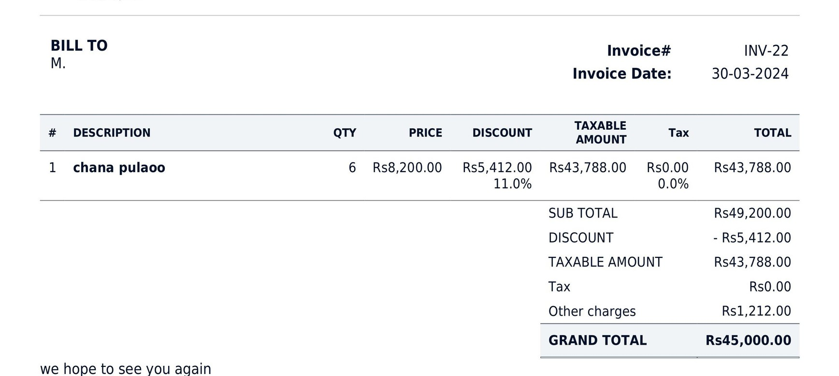

## “🌟 Community Impact & Feedback 🌟”

**The impact of the Iftar Drive was far greater than we could have imagined. As the sun set and people broke their fasts with the food we provided, their eyes reflected gratitude and relief. Many came forward to thank us — not just with words, but with heartfelt duas and emotional smiles. Some shared their stories of hardship, reminding us why such initiatives are not just necessary but sacred.**

**Volunteers, too, underwent a transformation. For many, it was their first time serving others on such a scale. They expressed how fulfilling it felt to give back, how the sense of unity made them feel connected not just to the community but also to something much bigger — a collective sense of purpose. This project became a mirror that reflected humanity at its best: selfless, united, and compassionate.**

**“Qoute”**

***"No act of kindness, no matter how small, is never wasted."***

***Aesop***

## “🌟 Conclusion 🌟”

**This Iftar Drive was not just a project — it was an experience that touched the heart, shaped character, and rekindled faith in humanity. In a world that often feels divided, this initiative reminded us of the power of unity, empathy, and collective action. The prayers we received, the tears of joy we witnessed, and the blessings we were showered with are etched in memory forever.**

**It changed me personally — gave me a reason to believe that even small steps can lead to big changes, that when we serve others, we heal parts of ourselves too. I walk away from this project with renewed determination to make community service not just a course requirement, but a lifelong commitment.**

**“Qoute”**

***“The smallest deed done is better than the greatest intention.”***

***John Burroughs***

## “🌟 Acknowledgment 🌟”

**I express my deepest gratitude to Sir Waqar Arshad, whose guidance, support, and belief in the power of real-world learning made this project possible. Your encouragement lit a spark in us to go beyond textbooks and step into the field with compassion and courage.**

**A heartfelt thank you to RSWS, RAS Society, and BZU Student Society, our pillars of strength and collaboration. Without your endless support, dedication, and shared vision, this drive would not have reached the heights it did. This journey would not have been the same without each one of you.**

**“Qoute”**

***“Alone we can do so little; together we can do so much.”***

***Helen Keller***

## “🌙 Final Reflection 🌟”

*"Feeding a hungry soul is not just charity — it is a silent prayer that rises beyond the skies. Maybe your one biryani box ended a mother’s wait for food... maybe your quiet smile eased the pain in someone’s heart. To provide Iftar during Ramadan is not merely a gesture — it could be the very deed that wipes away a lifetime of sins."*

**“And spend [in the way of Allah] from what We have provided you before death approaches one of you…”**

***Surah Al-Munafiqun (63:10)***

## “🌟 Video Links 🌟”



**“Link#1”**

[**https://www.instagram.com/reel/DGuHfJpoUX6/?igsh=MXE2dDE3bG9idGppaw==**](https://www.instagram.com/reel/DGuHfJpoUX6/?igsh=MXE2dDE3bG9idGppaw==)

**“Link#2”**

[**https://www.instagram.com/reel/DHBMeVXTLCT/?igsh=MXBpcGUzeTB4djRheg==**](https://www.instagram.com/reel/DHBMeVXTLCT/?igsh=MXBpcGUzeTB4djRheg==)

**“Link#3”**

[**https://www.instagram.com/reel/DHUFMWwIR1s/?igsh=eW95YmZ2a3AzYnpy**](https://www.instagram.com/reel/DHUFMWwIR1s/?igsh=eW95YmZ2a3AzYnpy)

**“Link#4”**

[**https://www.instagram.com/reel/DHS0VCMsAS1/?igsh=cnVsNHRkeWxwemN0**](https://www.instagram.com/reel/DHS0VCMsAS1/?igsh=cnVsNHRkeWxwemN0)

**“Link#5”**

[**https://www.instagram.com/reel/DHqQZH9t2FN/?igsh=YjBrZzI3MnU3dzI0**](https://www.instagram.com/reel/DHqQZH9t2FN/?igsh=YjBrZzI3MnU3dzI0)

## “🌟 My-Certificate 🌟”

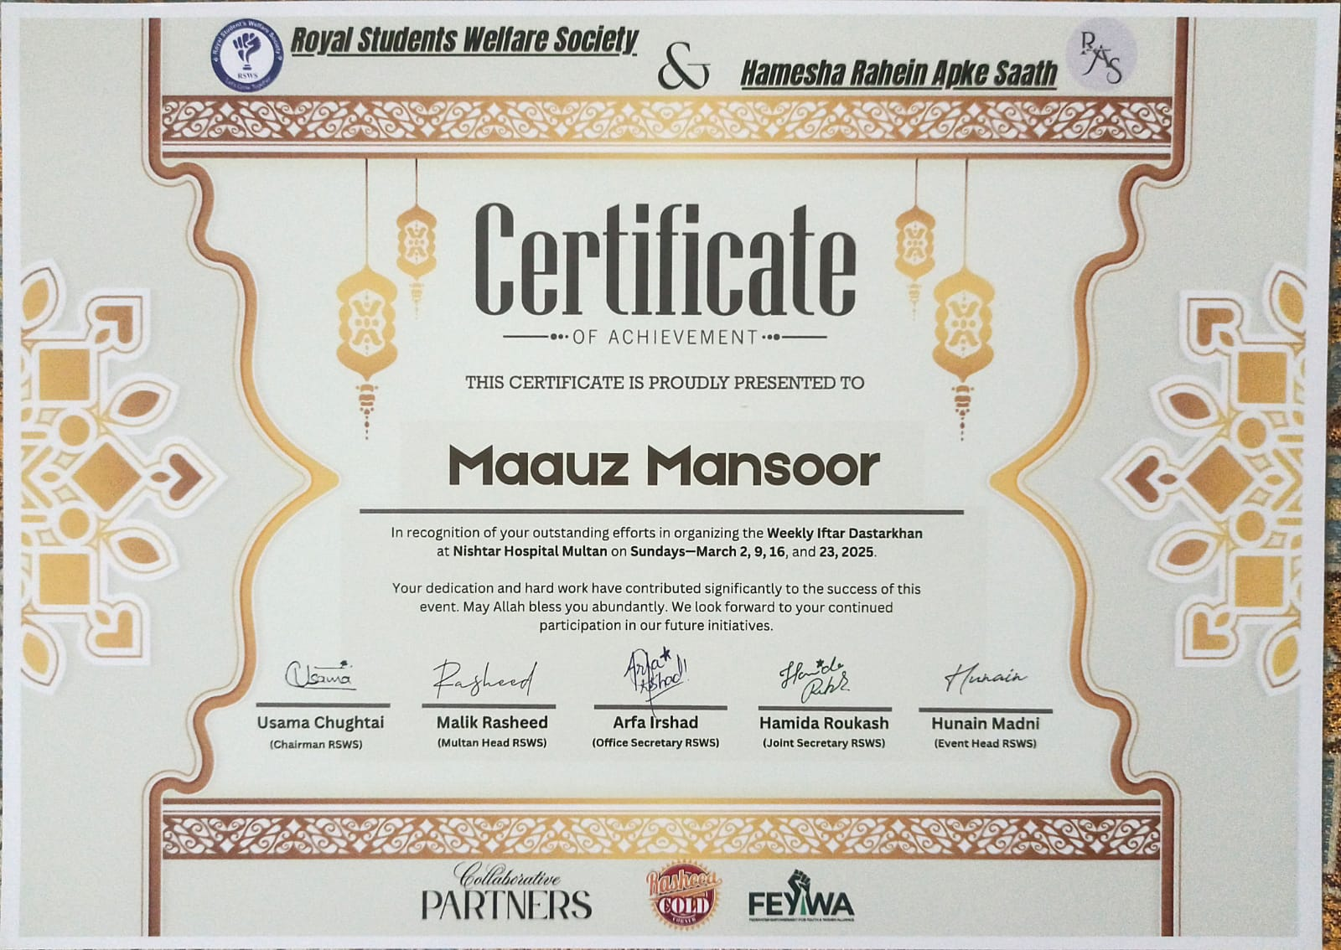

## “🌟 Other-Certificates 🌟”

**“**🌟 **Winter Drive 2k23** 🌟**”**

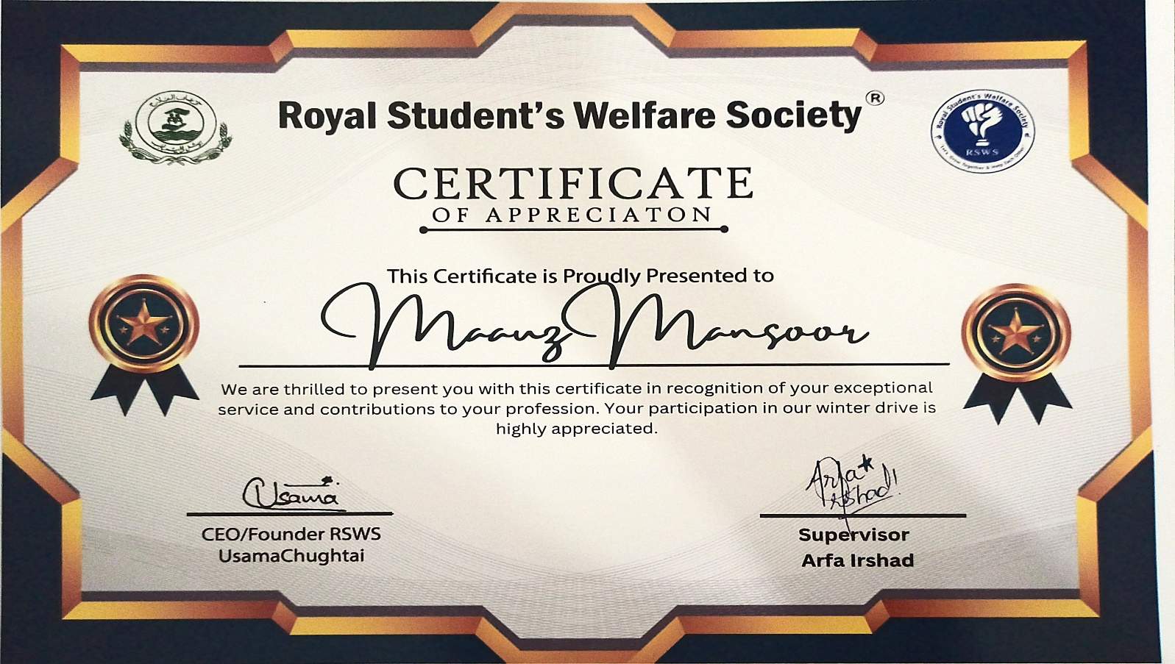

**“**🌟 **Organize-Session at BZU** 🌟**”**

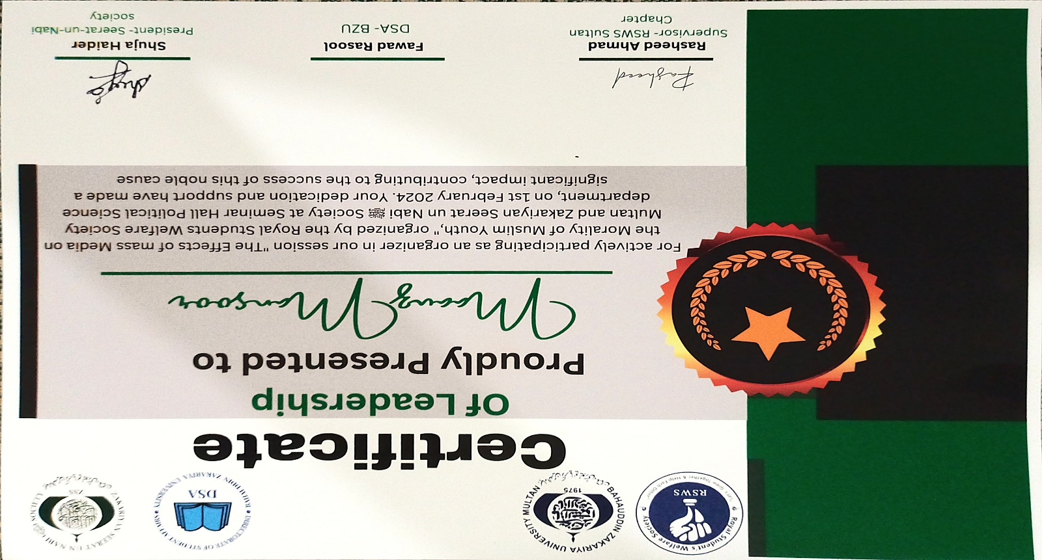

**“**🌟 **Old-Age Home Drive** 🌟**”**

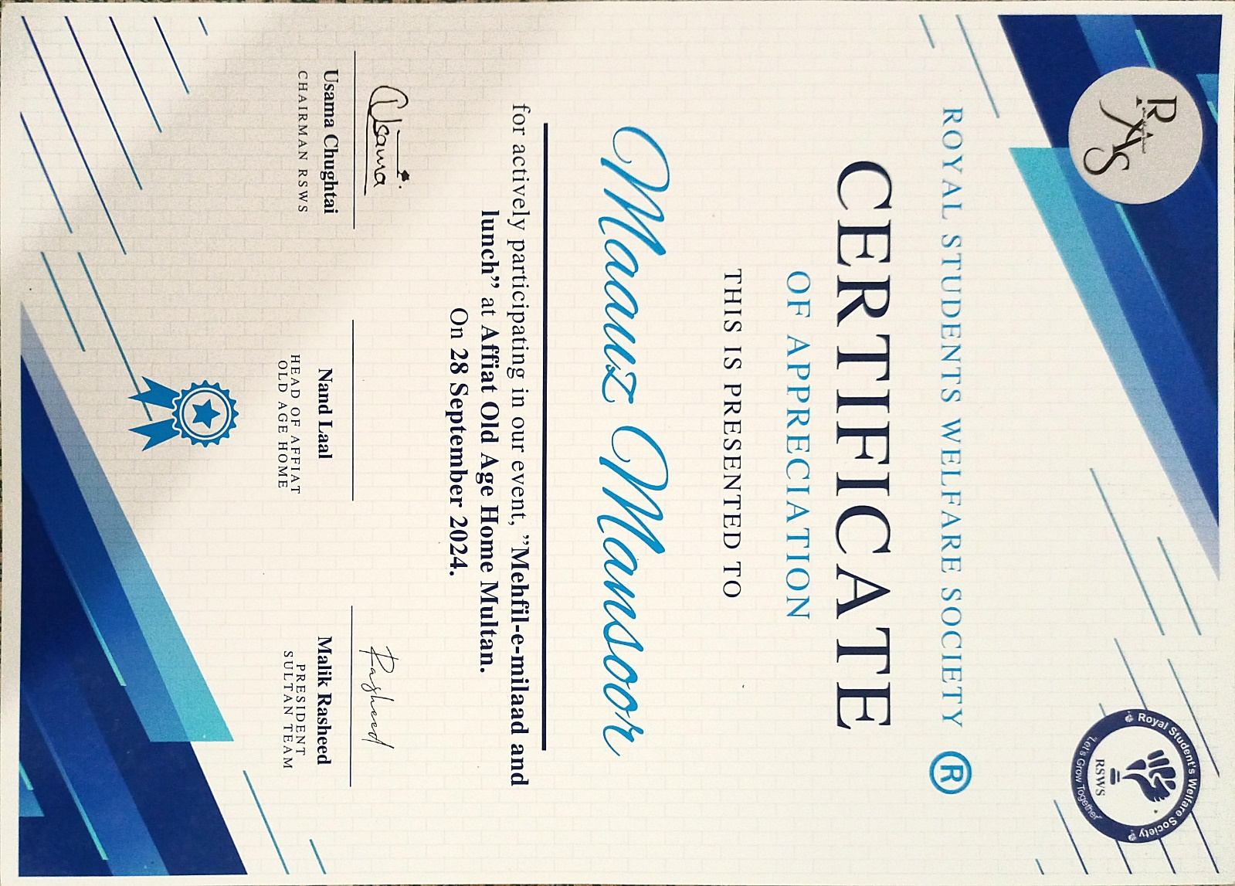

**“**🌟 **Bakra-Eid Drive** 🌟**”**

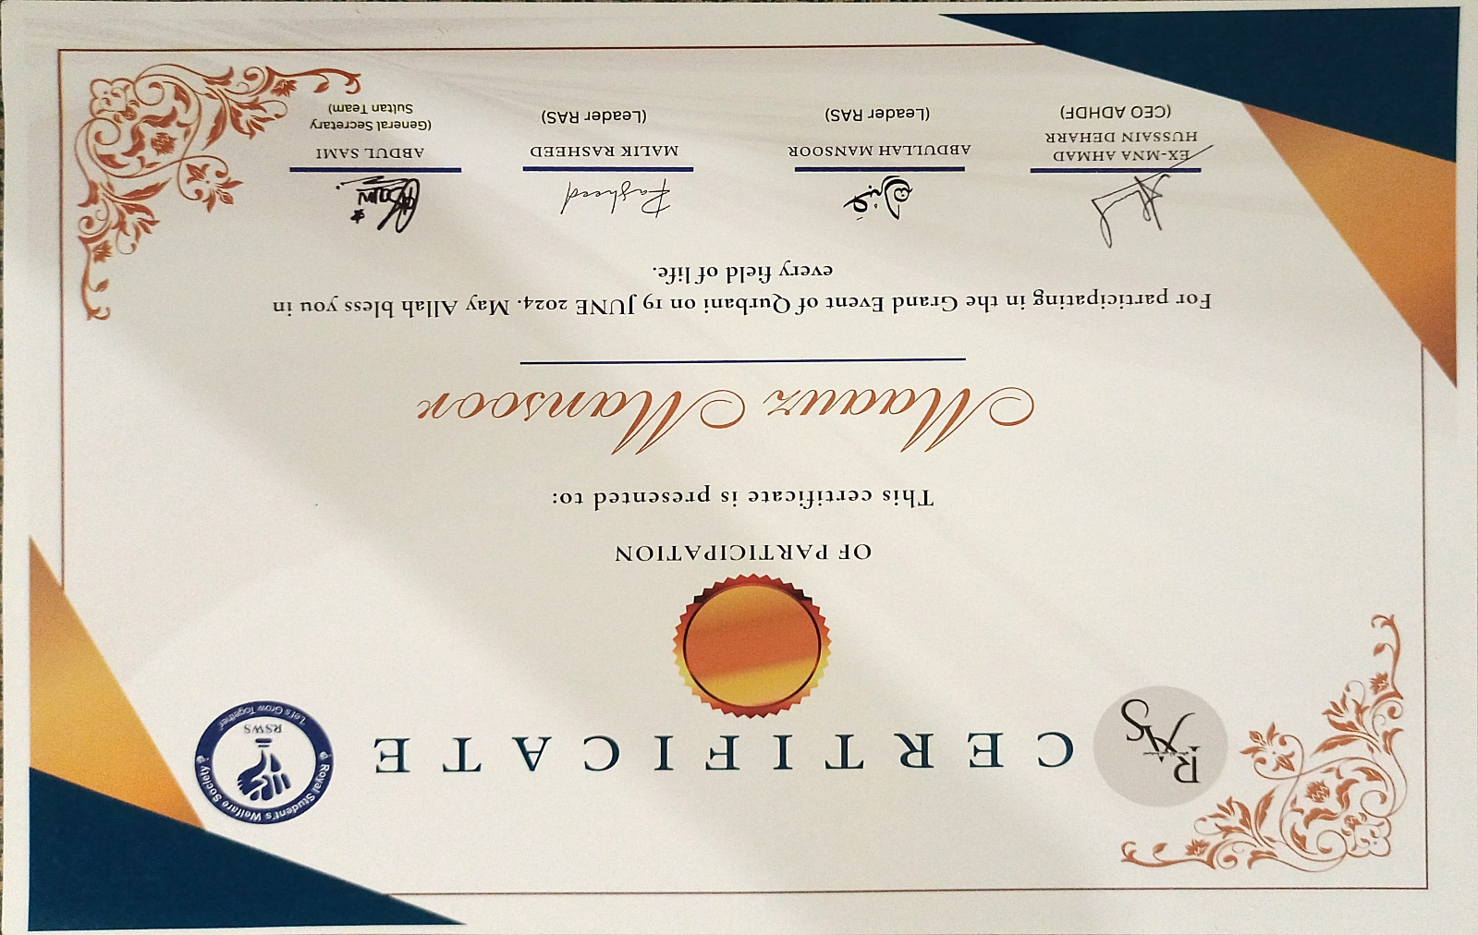

**“**🌟 **Winter-Drive 2k24** 🌟**”**

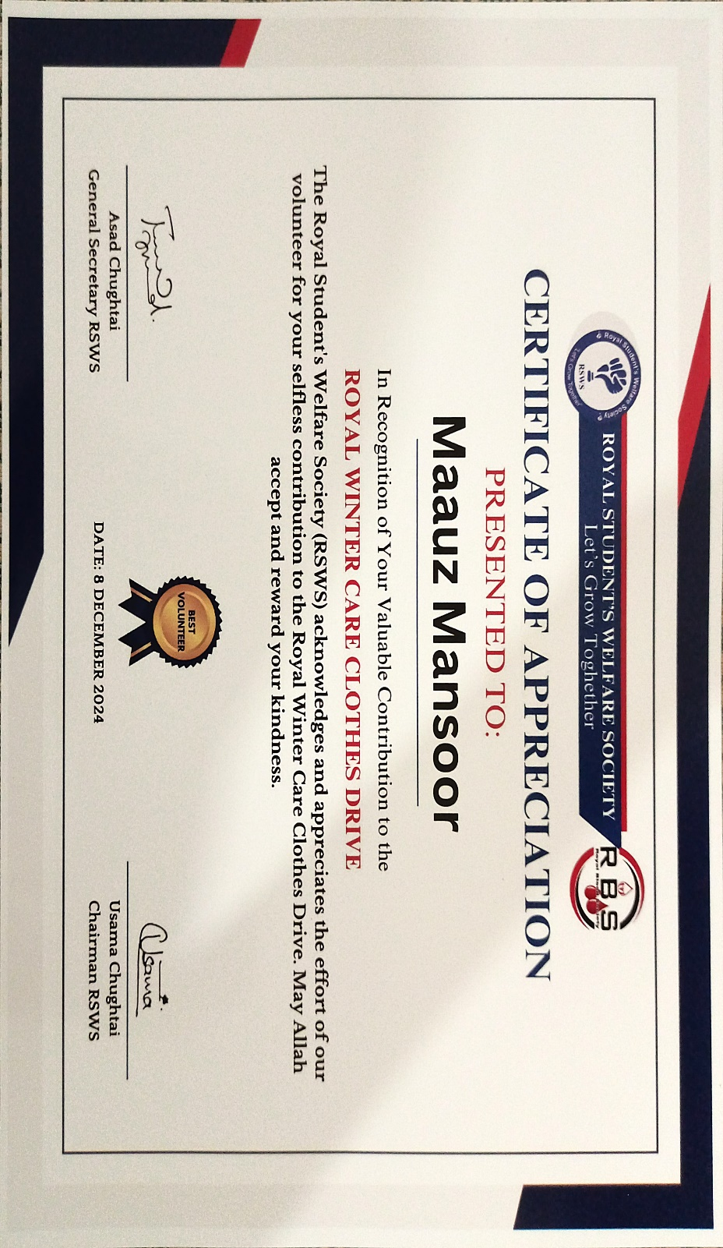

**“**🌟 **Madrassah-Drive** 🌟**”**

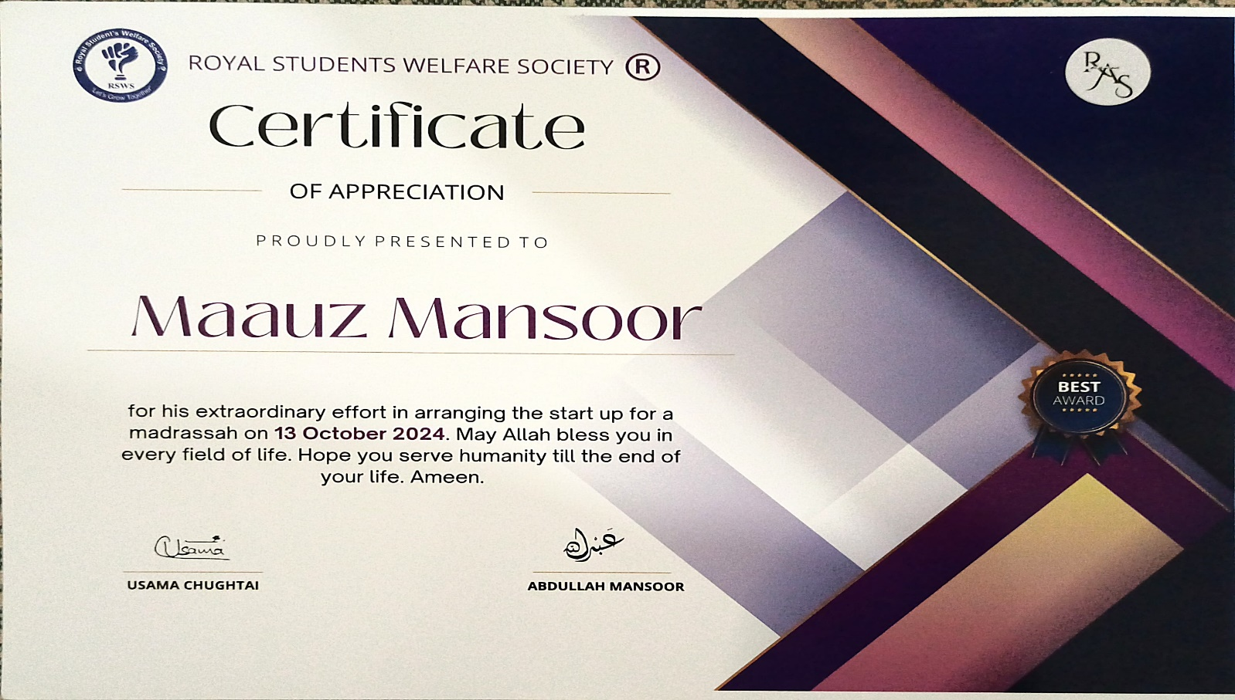

**“**🌟 **Orphan-Age Drive** 🌟**”**

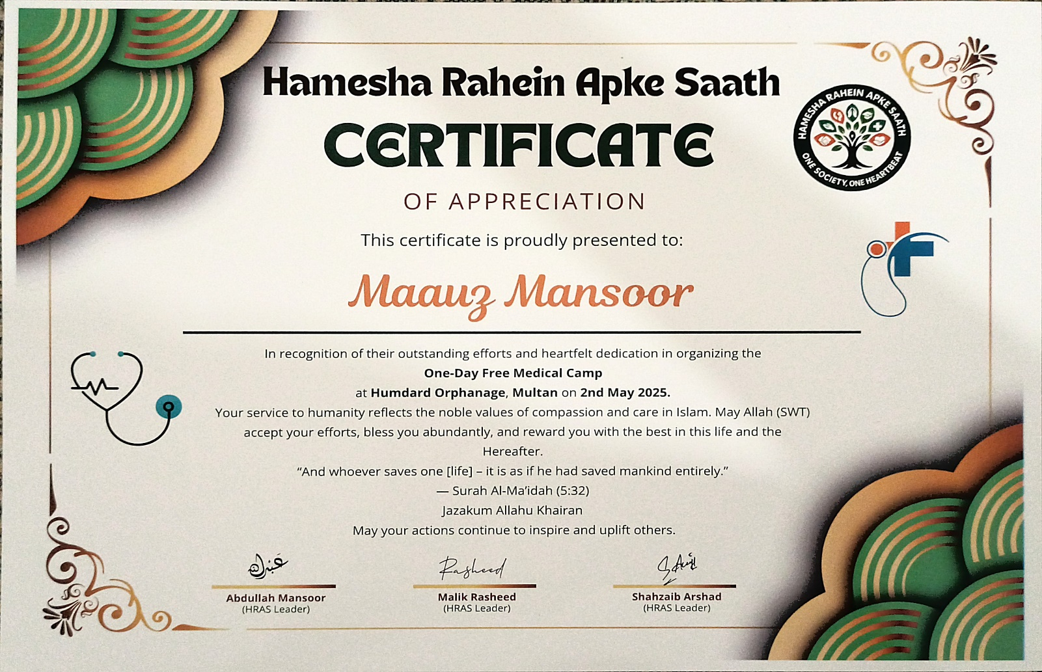

## The End !